

**PROTOCOL**to exercise

***VoIP***

|  |  |  |
| --- | --- | --- |
| Group / Class | Secretary | Signature |
| 5 / **3BHEL** | **HOFSTÄTTER A.** |  |
| Exercise- / Delivery date | Employee | Signature |
| 24th March 2014 |  |  |
| Teacher | Employee | Signature |
| GRASINGER |  |  |
| Grade | **Employee** | Signature |
|  |  |  |
| ***VoIP*** | | |
| **Used Programs**   |  |  |  |  |  | | --- | --- | --- | --- | --- | | Nr. | Device | Manufacturer | Type | Version | | 1. | **Phoner / Telephone (Mac)** | **-** | **Tool** |  | | | |

# Task

The task of this laboratory exercise was to build a connection with voice over IP.

Wireshark was to be used to see what the program Phoner does in the background, while connecting

# Setting up Phoner

Firstly, Phoner has to be set up right in order to be able to connect to the SIP-Proxy (Compact 5020). The IP of the Auerswald device is 10.81.229.70, so this IP has been set as the proxy/register. As the preferred kind of connection, UDP has been chosen. Because of the settings of the Compact 5020, a telephone number between 70 and 73 had to be chosen, for this exercise, 71 was the choice. For the Realm, the same IP as the one for proxy/register was the right one. The local Port was preconfigured as 5060.

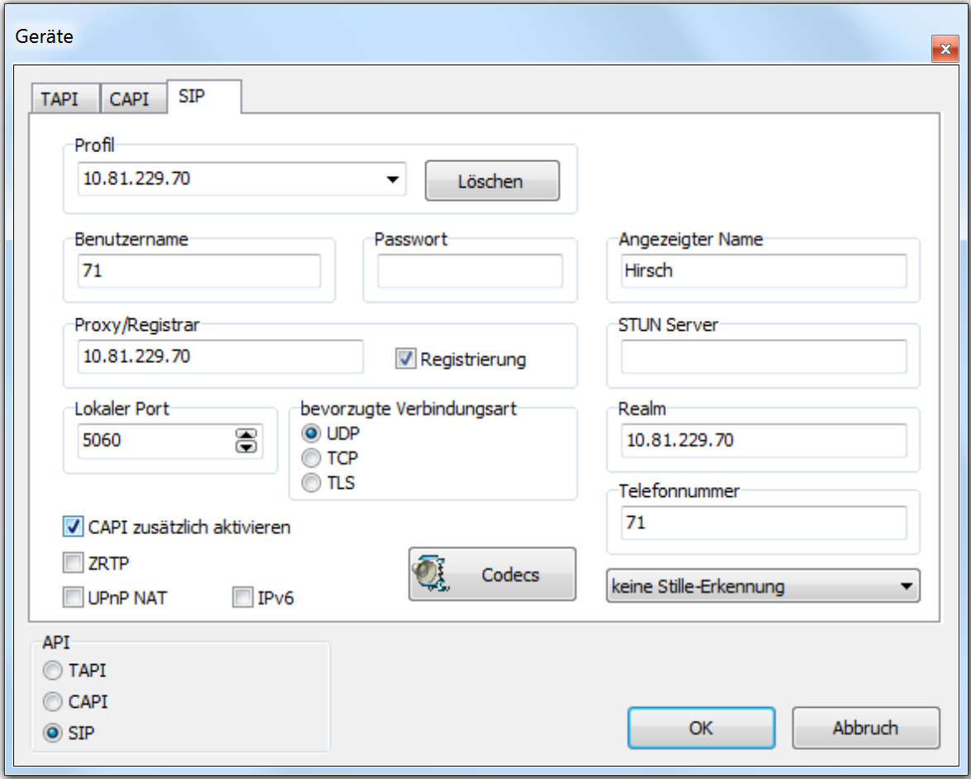

Now the same settings have to be set on a second device:

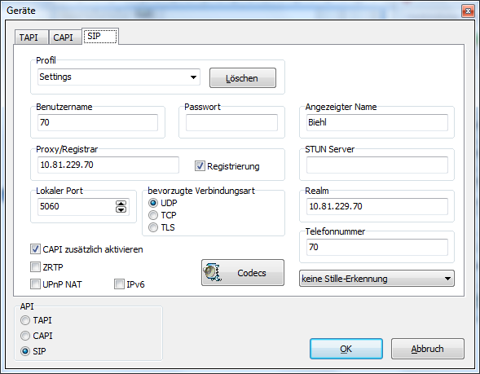

# Connecting to device

While trying to connect to another VOIP device, Phoner tries that by using following protocols





Wirshark showed, that the standard Protocol for VOIP, SIP was being used.

# Calling

If somebody calls you, a small message shows up at the screen. The name and the number are shown.

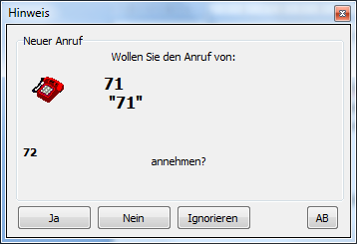

The call is always in the same format. The following diagram shows the process not only during also before and after the call. The structure is the same as in this case.

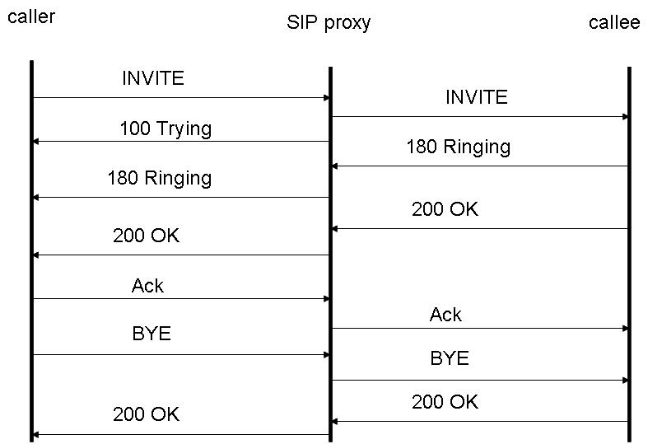

To prove that the construction correspondents the truth some screenshots from wireshark have been made.

Wireshark reports all packages which are sent.

Call try

Call try

Shortly after the call is trying it goes on ringing

Ringing



During the Ringing you can see some Packages with the timelap

Calldenied

Call denied

After the ringing the call was cancelled

Getting a call



If you get a call the beginning looks the same but as soon as you accept it the packages change a little bit.

During a call

udp during call

The normal packages over the right port can be seen.

Close the call

close the call

The call is going to be interrupted and then it ends